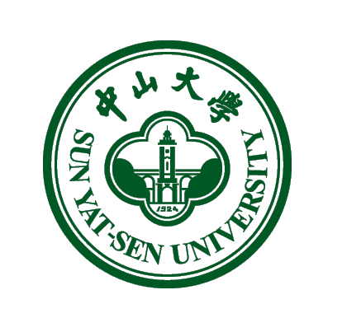

Sun Yat-sen University Handbook
For International Students

This handbook was produced by the Office of International Cooperation & Exchange, SYSU, and dedicated to the international students at Sun Yat-sen University.

Contents
Part 1: Introduction to SYSU 4
1. Brief Introduction 4
2. Important Facts & Statistics 4
3. Campuses Profiles 7
Part 2: Office of International Cooperation & Exchange 8
1. Welcome Message 8
2. About Us 8
3. Contact Us 9
Part 3: Academics 11
1. Registration 11
2. Medical Insurance 13
3. Fee Structures 13
1) Tuition Fees 13
2) Overall Insurance and Benefit Plan 15
3) Accommodation 15
4. Academic Rules 16
1) Rules for International Students 16
2) Offices in Charge of International Students’ Affairs 16
3) Class Attendance and Discipline 18
4) Examinations 22
5) Completion of Studies 22
6) Leaving the University 23
7) Off-Campus Housing 23
5. Visa 24
1) How to Read Your Visa 24
2) Important Notice: New Visa Extension Policy for Non-degree Chinese Learners 24
6. International Summer Program at SYSU 25
Part 4: Campus Life 27
1. Campus Cards 27
1) How to Apply 27
2) How to Top Up 27
3) How to Report a Missing Card 28
4) Campus Card Restrictions 28
5) Extra Charge in Canteens 28
6) Campus Card Service Center 28
2. Dining 29
3. Internet 31
4. Health 32
1) Campus Health Care 32
2) Hospitals 33
5. Postal Services 34
6. Financial 35
1) Changing Money 35
2) Banks & ATMs 37
3) Bank Hotlines 38
7. Libraries 39
1) Opening Hours 39
2) How to Apply For Borrowing Privileges 40
8. Shopping in 4 Campuses 40
9. Sports 42
10. Campus Shuttle Buses 43
11. Social Media 44
Part 5: Life in Guangdong 45
1. Transportation 46
1) How to Purchase and Use Yang Cheng Tong 46
2) Guangzhou Metro 46
3) City Bus 47
4) Taxis 51
5) Bicycles 51
6) Airport and Train Stations 51
2. Legal Matters 52
1) Immigration Bureaus 52
2) Consulates Located in Guangzhou 53
2) Emergency Numbers 54
3. Entertainment 54
1) Sports 54
2) Culture 54
3) Cinema 55
4) Nightlife 55
5) Recreation and Sightseeing 56
4. Dining 58
1) Cantonese Cuisine 58
2) Types of Restaurants 58
3) Recommended Restaurants in Guangzhou 59

Part 1: Introduction to SYSU
1. Brief Introduction
Sun Yat-sen University, founded in 1924 by the Chinese democratic
revolutionary Dr. Sun Yat-sen, is a preeminent academic and cultural center and the premier location for talent development in South China. Its main campuses are located in the modern metropolis of Guangzhou, known formerly in the West as Canton, with a branch campus nestled in the picturesque coastal city of Zhuhai. Under the direct supervision of the Ministry of Education of the People’s Republic of China, the University is strongly supported by both the Ministry and Guangdong Province and is a member of Projects 211 and 985, exclusive national higher education organizations at the vanguard of the drive to develop Chinese universities into world-class institutions. With a firmly established reputation as a top-ten university nationally and a burgeoning international profile, SYSU is moving from strength to strength as it strives to become a first-tier world university and global center of learning.

2. Important Facts & Statistics
As of 2014, Sun Yat-sen University boasts 3,463 full-time faculty and 50,485 full-time students. The University has four campuses (three campuses in Guangzhou and one in the coastal city Zhuhai), eight affiliated hospitals, two international joint institutes, eleven local research institutes, and twenty state-level research institutes.
There are more than 40 schools and departments in SYSU, as listed below:
- Department and schools for humanities and social sciences:

- Department of Chinese
- Department of History
- Department of Philosophy
- Department of Psychology
- International Business School
- Lingnan (University) College
- School of Asia-Pacific Studies
- School of Business
- School of Communiaction and Design
- School of Education
- School of Chinese as a Second Language
- School of Foreign Languages
- School of Government
- School of International Studies
- School of Information Management
- School of National Security
- School of Social Science Education
- School of Sociology and Anthropology
- School of Law
- School of Tourism Management
- Research Institute for Marxist Studies

- Departments and schools for natural sciences and engineering:

- Department of Earth Science
- School of Chemistry and Chemical Engineering
- School of Engineering
- School of Environmental Science and Engineering
- School of Geography and Planning
- School of Information Science and Technology
- School of Marine Sciences
- School of Mathematics & Computational Science
- School of Life Sciences

- School of Mobile Information Engineering
- School of Physics & Engineering
- School of Software
- School of Advanced Computing
- Sino-French Institute of Nuclear Engineering and Technology
- SYSU-CMU Joint Institute of Engineering

- Departments and schools of medical sciences:

- the Guanghua School of Stomatology
- School of Nursing
- School of Public Health
- School of Pharmaceutical Sciences
- Zhongshan School of Medicine

In addition, SYSU operates research units centered on educational and teaching reform, including the Department of General Education, Institute for Advanced Studies in Humanities, Liberal Arts College, School of Intellectual Property, and Yat-sen College, along with the Academy of Entrepreneurship, which focuses on training the next generation of entrepreneurs.

3. Campuses Profiles
SYSU has four residential campuses with a total area of 5.97 square
kilometers in Guangzhou, a thriving metropolis located on the banks of the Pearl River, and in Zhuhai, a coastal city on the shore of the South China Sea.
- South Campus: The main campus, located alongside the Pearl River
at Haizhu District in Guangzhou. With a total area of 1.21 square kilometers, south campus mainly hosts schools, departments, and facilities for natural sciences and humanities.
Address: No.135 Xingang Xi Road, Guangzhou, P. R. China, 510275

- North Campus：Located in the heart of downtown Guangzhou on
Second Zhongshan Road, covering an area of 0.20 square kilometers. It is the main campus for medical and health sciences.
Address: No. 74, Zhongshan Er Road, Guangzhou, P. R. China 510085

- East Campus：Established in 2004. Located at the northern end of the
Higher Education Mega Centre in Guangzhou, the campus covers an area of 0.99 square kilometers. It mainly accommodates schools in applied sciences
Address: Xiaoguwei Island, Panyu District, Guangzhou, 510006, P.R.China

- Zhuhai Campus：Located at Zhuhai, the campus covers an area of
3.57 square kilometers. Since its inauguration in 2000, Zhuhai campus has developed into a base for newly emerging disciplines and educational programs of international cooperation, and regional collaboration with HongKong, Macau and Taiwan.
Address: Tangjiawan, Zhuhai, Guangzhou, 519082

Part 2: Office of International Cooperation & Exchange
1. Welcome Message
On behalf of the entire University, the Office of International
Cooperation & Exchange at Sun Yat-sen University extends its warmest welcome to you as you join us on campus. We are so excited you have chosen to become a part of this learning community, and we are committed to doing everything possible to ease your transition. By arriving at SYSU to study, work, or teach, you are entering a vibrant and dynamic educational environment that is in the midst of an unprecedented period of growth and development. In this guide, you will find information that will help you get the most out of your time at SYSU. Below is more detailed information about what the Office of International Cooperation & Exchange does, as well as our contact information.

2. About Us
The Office of International Cooperation and Exchange (OICE) is the office at Sun Yat-sen University responsible for forging and maintaining ties with the outside world. A key element of the SYSU’s mission statement and vision for development is the further deepening of University-wide internationalization. This is a multi-faceted effort, and the OICE is at the vanguard of this push. The office is responsible for range of duties, including enrolling overseas students; initiating, implementing, and managing international partnerships; promoting SYSU abroad; recruiting foreign teachers and experts; maintaining strong ties with foreign institutions, as well as Hong Kong, Macau and Taiwan based institutions; organizing and hosting international conferences, among many others. For international faculty and students arriving at SYSU, the OICE will be present every step of the way to ensure successful integration into the SYSU community and to help your experience here reach its full potential.

3. Contact Us
- Office for International Students’ Affairs
South Campus
Tel: +86(20) 84110819, +86(20) 84036465
Fax: +86(20) 84005621
Email: admissions@mail.sysu.edu.cn
Working Hours: 8am-12am, 2:30pm-5:30pm
Address: Office for International Students’ Affairs, Sun Yat-sen University, No.135 Xingang Rd. West, Guangzhou, P.R. China, 510275

North Campus Office
Tel: +86(20) 87331675
Fax: +86(20)87333601
Email: zsumbbs@mail.sysu.edu.cn
Address: Office for International Students’ Affairs, Sun Yat-sen University, No.74 Zhongshan Rd.2, Guangzhou, P.R. China, 510080

East Campus Office
Tel: +86(20) 39332382
Email: lifangq3@mail.sysu.edu.cn
Address: Unit 1 Building No.3, Gezhi Yuan, Sun Yat-sen University, Higher Education Mega Center

Zhuhai Campus Office
Tel: +86 (756) 3668107
Email: yangmhui@mail.sysu.edu.cn
Address: Room 216, Li Yuan No.6 Building, Zhuhai Campus, Sun Yat-sen University, Tanjiawan, Zhuhai City

- Section for International Program
International Summer Program
Tel: +86 20 84111897
Fax: +86 20 84036860
E-mail: summerp@mail.sysu.edu.cn
Working Hours: 8am-12am, 2:30pm-5:30pm (Monday-Friday)
Address: Room 408, Zhongshan Building, Zhongshan University, Haizhou Disctrict, Guangzhou, China

International Faculty Affairs
Tel: +86 20 84114983
E-mail: liuych7@mail.sysu.edu.cn
Working Hours: 8am-12am, 2:30pm-5:30pm (Monday-Friday)

- Office for Hong Kong, Macao & Taiwan Affairs
Tel: +86 20 84115633
Working Hours: 8am-12am, 2:30pm-5:30pm (Monday-Friday)

Part 3: Academics
1. Registration
- On arriving at the university, newly enrolled students should register at the ISO within the designated period of time on the Admission notice. For registration, the student should submit the Admission Notice, Visa Application for Study in China(JW201/202), the Physical Examination Record for Foreigner （PERF）and his/her passport. The student is also required to prepare for 12 or more passport photos to obtain his/her student ID cards and other cards and the charges for them are to be borne by the student him/herself.

- Those who have taken X1 visa please go to the International Travel Health Center, according to the campus at which you will study, for the medical verification with “the Physical Examination Record for Foreigner (PERF)”, or taking another health examination for some or all of the items at the Center within the prescribed time.

International Travel Health Center | Location | Tel
Guangdong International Travel Health Center | #207 Long Kou Rd., West, Tianhe Dong, Guangzhou. | 020-38259306  020-38259322
Zhuhai International Travel Health Center | Suite 133#, Qiangguang Rd., Gongbei, Zhuhai (to the west of the Gold Leaf Hotel) | 0756 - 8889496

- The newly-arrived students who come to the University with X1 visas
should apply to the Division of Aliens and Exit-Entry Administration of Guangzhou Municipal Public Security Bureau (Those who study on the Zhuhai Campus will have to apply to the Division of Aliens and Exit-Entry Administration of Zhuhai Municipal Public Security Bureau) for residence permits within 30 days after their arrival in China. Failure to do so will subject applicants to a penalty by fine. Please find the contact information below:
 | Location | Tel
The Division of Aliens and Exit-Entry Administration of Guangzhou Municipal Public Security Bureau | 6th floor, No. 155 Jiefang Rd., South, Guangzhou. | 020-83115755,  020-83115894,  020-83115895
The Division of Aliens and Exit-Entry Administration of Zhuhai Municipal Public Security Bureau | No. 493, Xinghua Rd., New Xiangzhou, Zhuhai City (South Gate of the Sports Center) | 0756 – 8640557,  or 008640558

- CONTINUING DEGREE STUDENTS or advanced students are
required to register with their Student ID cards and passports at the ISO within one week of the commencement of each semester. Those who cannot register on time must ask for permission from the office. Failure to do so will be considered as truancy.

- FULL SCHOLARSHIP STUDENTS will be awarded monthly
allowance upon their registration within the period designated by the university.

- Those who TRANSFER to Sun Yat-sen University from other
institutions of learning in China are also required to register at ISO upon their arrival at the university. In line with the policy from the Public Security Bureau, if the students are holding residence permits which are still valid, they will have to process original copies of the official letters issued by the Office for International Students’ Affairs of the institutions of higher learning in China at which they have been studying. Only by completing these procedures can they apply for renewal or change in status of residence permits.
Note:
- Those who cannot register within the designated time should ask your school/depart & ISO for leave. Meanwhile, you are required to get agreement letter from your school and then hand the agreement letter on to ISO.
- If you don’t submit a request for leave or your request not approved by the University, and fail to register within TWO WEEKS, you will be regarded as voluntarily dropping out.

2. Insurance
According to the regulations of Ministry of Education, international students who study in the Chinese universities must purchase the compulsory medical insurance: RMB 400 per semester, RMB 800 per academic year.

3. Fee Structures

1) Tuition Fees
- For Non-Degree Chinese language learners
Tuition: RMB 17, 400/person/academic year;
RMB 8, 700/person/semester
Registration fee: RMB400
Learning Materials: Prices vary by book and class.

- For long-term programs (RMB/ person/ academic year):
Categories | Liberal Arts/ Managerial Science |  | Natural Science/ Engineering |  | Medical Science/ Art/P.E.
Categories | Chinese language programs | English language programs | Chinese language programs | English language programs | Chinese language programs | English language programs
Undergraduate Programs | 23,000 | 26,000 | 30,000 | 33,800 | 45,000 | 48,000
Master Programs | 27,000 | 30,000 | 36,000 | 39,000 | 50,000 | 55,000
Ph.D. Programs | 30,000 | 34,000 | 42,000 | 44,200 | 60,000 | 65,000
IMBA Programs (both offered by Lingnan (U) College and Business School) | N/A | 90,000 | N/A | N/A | N/A | N/A
Non-degree Courses | 23,000 | 23,000 | 30,000 | 30,000 | 45,000 | 45,000
Non-degree Advanced Courses | 27,000 | 30,000 | 38,000 | 39,000 | 45,000 | 60,000
N/A | Registration Fee: RMB 400  Lingnan (U) College IMBA Program Registration Fee: RMB 800 |  |  |  | Registration Fee: RMB 600  Zhongshan School of Medicine MBBS Program in English  Registration Fee: RMB 800

- For short-term courses
Tuition Fee: RMB 3,800/per month; Registration Fee: RMB 400
(This program accepts group applications ONLY.)

2) Overall Insurance and Benefit Plan
The overall insurance and benefit plan for International Students (Loss of Life Insurance, Accidental Injury Medical Treatment Insurance and Hospitalization Medical Insurance only) is RMB800/person/year.

3) Accommodation
Campus | Dormitory | Type | Price
South Campus | International Student Dormitory | Air-conditioned Single Room | RMB 1,650/ person/ month (Room rate shall be collected for at least 5 months at one time.)
South Campus | International Student Dormitory | Air-conditioned Double Room | RMB1,050/ person/ month (Room rate shall be collected for at least 5 months at one time.)
South Campus | No. 103 Dormitory | Air-conditioned Single Room | RMB 9,000/person/semester
South Campus | No. 103 Dormitory | Air-conditioned Double Room | RMB 4,500/person/semester
South Campus | No. 351 Dormitory | Air-conditioned Double Room | RMB 4,800/person/academic year
North Campus | International Student Dormitory | Air-conditioned Single Room | RMB 1,500/person/month (Room rate shall be collected for at least 5 months at one time.)
North Campus | International Student Dormitory | Air-conditioned Double Room | RMB 950/person/month (Room rate shall be collected for at least 5 months at one time.)
East Campus | International Dormitory (No 3. Gezhi Yuan) | Air-conditioned Single Room | RMB 9,000/person/academic year
East Campus | International Dormitory (No 3. Gezhi Yuan) | Air-conditioned Double Room | RMB6,000/person/academic year
Zhuhai Campus | Student Dormitory | Air-conditioned two Person’s Room | RMB4,500/person/academic year
Note: Monthly bills for running water, electricity, telephone, and cable TV, as well as the deposit are not included in the room rate. Please check the website of Office for International Students’ Affairs, SYSU: http://iso.sysu.edu.cn/sh/ --“Guide for Living”.

4) Refund of Self-support Student
Those who would like to apply for dropping out of school after the payment of school fees, 80% of the tuition will be refunded before the classes begin. After the classes begin, only 50% before April 30 (including the current day for the Spring Semester) for the first half year. No refund will be made after May 1. For the second half year, 50% of the tuition will be refunded before October 30 (including the current day for the Fall Semester). After November 1, no refund will be made. Those who have applied for the extension of visas or residence permits cannot get the refund until they change the visa or cancel the residence permits. No refund will be made for students being expelled from school.

4. Academic Rules

1) Rules for International Students
- Abide by the pertinent laws and regulations of the Chinese government;
- Observe regulations formulated by the university;
- Study hard and complete assignments conscientiously;
- Show respect for faculty members and staff;
- Preserve unity among classmates;
- Pay attention to personal health and wellness;
- Respect the social customs and habits of the Chinese people;
- Maintain and promote friendship and unity among peoples of all countries.

2) Offices in Charge of International Students’ Affairs
- Office for International Students’ Affairs
Office for International Students’ Affairs (ISO) is an administration office for international students at Sun Yat-sen University. ISO takes responsibility for recruitment and foreign affairs of international students,, electronic registration for degree students’ diplomas, granting monthly living allowance for scholarship students and conducting annual review status for Scholarship, assisting students in getting necessary documents or visas, helping students to claim medical insurance compensation. It also coordinates with the Dean’s Office/Dean’s Office of Medical Education, the Graduate School, the Office for International Student Dormitories and other related departments in other work and activities including teaching, noviciate, practice, and accommodation and so on.
For contacts please refer to Part 2

- Student Affair Office
Student Affair Office takes the responsibility for administration of daily affairs of undergraduate international students, including subsidizing, penalty for violating disciplines and regulations, offering necessary documents and certificates, training and administrating the school counselors for international students.
Tel: +86 20 9332222 (The Guangzhou East Campus)
+86 756 3668055/3668166(The Zhuhai Campus)

- The Dean’s Office/Dean’s Office of Medical Education
The Dean’s Office/Dean’s Office of Medical Education is responsible for the administration of teaching affairs in undergraduate programs, such as handling students’ records, examining syllabi and other pertinent work of the departments concerned. Regular teaching work is the responsibility of the related departments or colleges.
Tel: +86 20 84112574 (Guangzhou South Campus)
+86 20 87331247 (Guangzhou North Campus)

- The Graduate School
The Graduate School is in charge of the administration of teaching affairs in postgraduate programs, such as evaluating applicants’ eligibility, admitting students, handling students’ records, conferring degrees, etc. Regular teaching work is done by the academic departments, colleges or tutors concerned.
Tel: +86 20 84111687 (Guangzhou South Campus)
+86 20 87331232 (Guangzhou North Campus)

- Room and Board
The Zi Jing Yuan Hotel on the Guangzhou South Campus administers both the International Student Dormitories and the Foreign Guest House, including a restaurant and an international student canteen. It provides board and lodging and other related services for international students and foreign guests. The Dorm Administrative Center and the Dietetical Administrative Center are in charge of room and board for the international students studying in the Guangzhou North Campus. The Offices for Logistics are responsible for arranging the rooms for the students on the Zhuhai Campus and the Guangzhou East Campus.
Tel: +86 20 84111889 (Guangzhou South Campus)
+86 20 87331648 (Guangzhou North Campus)
+86 756 3668080（Zhuhai Campus）
+86 20 39332196（Guangzhou East Campus）

3) Class Attendance and Discipline
- International students are expected to attend classes in accordance
with class timetables. Absence from school without asking for leave, being late for class, or leaving early from classes without reason are not allowed.

- For degree students, in the case of absence from class due to
illness, a certificate from the doctor must be presented to the teacher. In the case of absence from class to attend to private affairs, a prior statement must be submitted to and approved by: a) the teacher, for absences within 3 days; b) the director of the department or college, for absences within 4 - 7 days; or c) the head of the Dean’s Office or the Graduate School, for absences more than 7 days. (Leave applications for full Chinese Government Scholarship students should be approved by the ISO first).

- Whether being on sick leave or private affairs leave, degree
students whose absences from class accumulatively exceed 2/3 (two-thirds) of the total number of weeks in a semester will be regarded as voluntarily dropping out.

- Degree students who are absent from class without asking for
leave or without gaining approval by asking for leave are considered truant. Those who are absent for 2 weeks continuously or 50 or more class hours in accumulation in one semester will be asked to quit school and those who are absent for less than 50 class hours will be handled in accordance with the following principles:

- A warning will be given to those who are absent for 2–4 days continuously or 10–20 class hours accumulatively.
- A serious warning will be given to those who are absent for 5–6 days
continuously or 21–30 class hours accumulatively.
- A demerit will be registered for those who are absent for 7–8 days continuously or 31– 40 class hours accumulatively.
- Students absent for 9–10 days continuously or 41–50 class
hours accumulatively will be placed on probation. Students resuming classes, whether their leave is due or not, are expected to report in time to the office of the departments or colleges concerned, as well as the to the ISO. In case they have to extend their leave, they should go through formalities of extension in person or ask someone else to do it. Otherwise, they will be considered truant.

- Whether a degree student has to repeat a course or not is decided
in accordance with the regulations set by the University.

- International students who commit any of the following infractions
will receive a warning, serious warning, or a demerit, or will be put on probation or be expelled from school according to the seriousness of their cases (The cases will be handled in accordance with “Regulations of Penalties for Sun Yat-sen University Students)”:
- Violation of the Chinese criminal law that constitutes a criminal offence;
- Breach of school discipline;
- Damaging public property, fighting, creating a public disturbance, or committing other undesirable behavior.

Once the decision regarding the above-mentioned disciplinary
measures is made, the student will be notified. Additionally, a written
notification will be also sent to his/her diplomatic or representative
institution in China, or to the relevant organization at home. Students
who must suspend study from the university should return home
immediately.

The disciplinary measure against him/her may be lifted if the student
put on probation has clearly corrected his/her misconduct within half
a year. If the student fails to correct his/her misconduct or repeats the
misconduct while on probation, he/she will be expelled from school.

- Students who observe the school’s regulations and excel in their
studies will be commended and granted certificates of merit or awards and recommendeds to study for higher degrees.

- For such matters as the suspension of studies, dropping out,
transfer of school, extension of study or change of specialties (For change of specialties, please refer to the regulations by “Administration Rules for Sun Yat-sen University Students”) , the degree student must submit his/her application in advance to gain approval (Extension of study or change of specialties must be applied for by the end of the first semester). With the permission from the diplomatic or representative institutions of his/her own country in China, the Chinese Government Scholarship student should submit his/her application simultaneously to the China Scholarship Council via ISO.

- Degree students who lose their student ID cards are required to go
through certain procedures so that the university may issue them new ones. For this purpose, undergraduate students should go to the Administration Section of the Dean’s Office, post-graduate students to the Graduate School, and the non-degree students to the International Student Office, where they have to fill out an application form explaining where, when and how the card was lost, provide a passport-sized photo and pay a service fee.

- Non-degree student’s attendance to classes will be handled in
accordance with the regulations for degree students.

4) Examinations
- Required and elective courses are graded with the 100-mark system.
- Those who are absent from school (including truants and those on
leave) for more than half of the total class hours of a course are not
eligible to take the examination for the course.
- Examinations or tests for non-degree Chinese learners will be
handled in accordance with requirements by the School of Chinese
as a Second Language.

5) Completion of Studies
- A certificate of studies at Sun Yat-sen University will be issued to
the non-degree students who have attended the classes as required and passed the examinations. Those who do not take or who fail to pass the examinations will be given only a written statement certifying they have studied at the University.

- A Certificate of Advanced Studies will be issued to the non-degree
advanced students who have fulfilled their research projects and submitted a research report which was approved by their supervisors’.

- A Certificate of Graduation will be awarded to those
undergraduate and graduate students who have completed all prescribed courses, accumulated sufficient credits and passed all examinations. A degree, as well as its English translation, will be conferred to those who meet the standards stated in the “Interim Measures for the Implementation of the Regulations of the People’s Republic of China on Academic Degrees”.

6) Leaving the University

Before leaving the university upon graduation or completion of

their studies, students are required to return all their borrowed articles and books to the departments concerned. They should return the student ID cards, and medical treatment cards to the ISO too.

Students should inform the service desk of the International

Student Dormitory or Students Apartment Buildings of their departure and return their room keys and all the borrowed daily necessities one day before their departure. Self-funded students must pay off rents and any other expenses before departure.

Students are expected to leave the university within two weeks of

their graduation or completion of studies. Those who wish to postpone their departure from China for special reasons must come to the International Student Office to account for the delay. Extension may be approved but it must not exceed a month. Fees will be charged in accordance with the regulations.

7) Off-Campus Housing
- International students may choose to live off-campus, but they
must register at the ISO with their home addresses and telephone numbers, register at the local police station and apply for the “Registration Certificate of Temporary Residence for Visitors” in accordance with Chinese laws. While you are living off campus, please make sure that housing information is trust-worthy, your apartment is in a good and safe environment and your rental procedures are completely legal, and make sure the landlord registers at the local police station to obtain the appropriate rental permissions. In short, your rental procedures must be thorough, legal and authentic.

- We often find that some students’ addresses and contact
information change while they are studying in Sun Yat-sen University. In this case, you should promptly report your new address, phone number and e-mail address to the ISO, because this office often sends out official notifications. When such situations arise, it is essential that their information databases be updated. The ISO maintains a strict policy of privacy over individuals’ contact information.
- Please read “Information for the International Students Who
Live off the Campus” carefully.

5. Visa

1) How to Read Your Visa
If you cannot read your visa then you will not fully understand your
legal status as a student in China. In order to make your studies and life in China as smooth as possible, we will guide you through to learn about the following three common types of visas. Please refer to Appendix 1 for detailed information.
- VISA X1
- VISA X2
- Residence Permit

2) Important Notice: New Visa Extension Policy for Non-degree Chinese Learners
In line with the latest regulations issued by the Guangdong Provincial Public Security Department (GPPSD) and the Guangdong Provincial Bureau of Education (GPBE), we would like to draw your attention to the NEW REQUIREMENTS regarding Visa extension:

Ⅰ.Beginning from March 1st, 2015, Class Attendance Rate Certificate and Transcripts for the previous semester are required for continuing non-degree Chinese learners who need to extend their Visas. Visa CAN NOT be extended for non-degree Chinese learners with a Class Attendance Rate below 80% among total class hours required or for those with a record of poor academic performances.

Ⅱ. Please carefully note that the non-degree Chinese learners with Class Attendance Rate below 80% whose Visas CANNOT be extended WILL BE UNABLE to continue their study at SYSU.

Ⅲ. All students are required to attend classes regularly in accordance with their class schedules. Absence from school without asking for leave, or being late for classes or leaving early without reasons are strictly prohibited.

6. International Summer Program at SYSU
Starting in 2010, Sun Yat-sen University (SYSU) has welcomed students from around the world to the International Summer Program (ISP) in July every year. The program has emerged as an outstanding platform for international exchange between students, faculty, and the entire University community. The highlights of the program include Chinese language instruction, social and cultural studies, and business management studies. An emphasis is on fields related to the Pearl River Delta region, the area in South of China that SYSU calls home.
The region is widely known as the engine of Chinese economic growth and it is from here that the country set off on its policies of economic opening and reform over thirty years ago. The culture and development of this region are beginning to attract the world’s attention. The summer program covers a wide range of topics, reflecting the past 10 years of economic achievements and recent challenges to the region as well as to the country. Except in-class sessions, local company visits, and cultural excursions as part of the program. Being part of this program means meeting new people, approaching new cultures, and tapping into new potentials.
Students from various cultural backgrounds will be recruited to study in the same classroom. SYSU will provide a cross-disciplinary, cross-cultural, and cross-border educational atmosphere, in addition to a host of colorful campus cultural activities for ISP students to broaden their international horizons and enhance their international competencies.
For more information about the international summer program in SYSU, please refer to the separate handbook for summer program students or visit http://summerprogram.sysu.edu.cn/.

Part 4: Campus Life
1. Campus Cards
The campus card is a digital and multi-functional card which can be
used by students, teachers, and staff as personal identification. It functions as a student ID card, employee ID card, library card, and medical card on campus, as well as a payment tool for dining, shopping, surfing the internet on campus, and transportation between the four campuses. It is important to note that the campus card is distinct from the official student ID (a green booklet).

1) How to Apply
You can apply for the campus card through the Office for International Students’ Affairs or through Office of International Cooperation and Exchange. Usually upon your registration with the University, the university staff from relevant offices will provide an application form and help with your campus card registration. Students should first obtain their official student ID (a green booklet) from their college or department. This ID can then be used to apply for the campus card.

2) How to Top Up
- Cash top-up: You can top up your campus card in the campus card service points in the campus canteens with cash during meal time. The canteens will have a window where you can hand your card and some cash to a worker. Or you can top it up with the card top-up machine at the gates of most canteens.
- Machine top-up : You can top up your campus card with the campus
card top-up machines, which are usually located on the 1st floor of
every dormitory and every student cafeteria.

3) How to Report a Missing Card
There are a few ways to report a missing campus card, and the most
direct way is to visit the campus card service center with your student ID and passport (or other ID). You can also do so with the card top-up machines or by visit http://card.sysu.edu.cn, or by telephoning: 020-84110453 (Guangzhou) / 0756-3668811（Zhuhai）.

4) Campus Card Restrictions
You can only use 30 RMB with the campus card within a certain
period of time per day (00:00-10:00, 10:00-16:00, 16:00-24:00). If you use more than 30 yuan, you will be prompted to input your card password.
**For non-Chinese citizens, the default password for the campus card is 888888.

5) Extra Charge in Canteens
Without a campus card, you will be charged an extra 30% when you
dine in the canteens and the process of paying for the meal will be more complicated. So don’t forget to take your campus card with you when you dine at the canteens.

6) Campus Card Service Center
For other campus card services (such as cancellation, inquiry, consultation, lost and found, etc), please contact the campus card service center in relevant campuses, or visit http://card.sysu.edu.cn for more information.
Campus | Service Hours | Location | Hotline
South Campus  Card Service Center | Mon/Tue/Wed/Fri: 9:30-16:30  Thu:9:30-13:00  Sat: 11:00-13:00 | By the Post Office | +86 20 84036866 (Guangzhou)
North Campus | Mon/Tue/Wed/Fri: 9:30-16:30  Thu: 9:30-13:00 | On the South of the Staff Cafeteria | +86 20 84036866 (Guangzhou)
East Campus | Mon/Tue/Wed/Fri: 9:30-16:30  Thu: 9:30-13:00 | On the first floor of activity center and by the ATM of ICBC | +86 20 84036866 (Guangzhou)
Zhuhai Campus | Mon/Tue/Wed/Fri: 9:30-16:30  Thu: 9:30-12:00 | On the first floor of the Liyuan 2nd Building | +86 756 3668500 (Zhuhai)

2. Dining
Students can use their campus cards to eat at any of the universities cafeterias. There are also numerous affordable dining options nearby the SYSU’s gates, particularly the Main (South) Gate and the Small North Gate.
South Campus | Location | Tel
Graduate Student Cafeteria | By the western Stadium. | 020-84114486
Student Cafeteria | 1-2/F, Building No. 107, Student dormitory area | 020-84113366
Chun Hui Yuan Student Cafeteria | 1-2/F, Bldg. No. 353 | 020-84111233
Zijing Yuan Restaurant | Behind the School of Foreign Languages | 020-84111887  020-84110813
International Student Cafeteria | the 1st floor of Zijing Yuan Restaurant | 020-84111887  020-84110813
The Muslim Restaurant | 1/F, Building No. 107, by the student cafeteria | 020-84112428
Kang Le Yuan Restaurant | Building No. 609, Pu Yuan District | 020-84112597  020-84112668
Ju Yuan Restaurant | Near the west gate | 020-84112992
Pu Yuan Restaurant | Pu Yuan Road, Pu Yuan District | 020-84113772  020-84113925
Wing Kwong Hall | North-east Bldg. 350, Opposite the Lingnan (University) College | 020-84112138
South Lawn Coffee Shop | North-east Bldg. 347 | 020-84113682
East Campus | Location | Tel
No.1 Student Cafeteria | Building No.11, Ming De Yuan | 020-39333005
No. 2 Student Cafeteria | 2/F, Building No.11, Ming De Yuan | 020-393332823
Juncheng Restaurant | 1/F, Administration & Conference Center | 020-39332833
No.3 Student Cafeteria | 1/F, Building No.11, Zhi Shan Yuan | 020-39354259
No.4 Student Cafeteria | 2/F, Building No.11, Zhi Shan Yuan
Dongyuan Restaurant | 1/F, Dongyuan Hotel | 020-9332268
North Campus | Location | Tel
Student Cafeteria |  | 020- 87331590
Jing Ai Tang | 1-2/F Staff Apartment on Guanghua Road
Xinglinge Restaurant | Next to the Staff Cafeteria | 020- 87331755
International Student Cafeteria | West of the International Student Dormitory | 020- 87334268
Zhuhai Campus | Location | Tel
LI Yuan Student Cafeteria | Building No. 13, Li Yuan | 0756-3668230
Rong 1 Student Cafeteria | 1/F, Building No. 4, Rong Yuan | 0756-3610189
Rong 2 Student Cafeteria | 2/F, Building No. 4, Rong Yuan | 0756-3668141
Suiyue Lake Restaurant | By Suiyue Lake | 0756-3668806

3. Internet
You can apply for internet access with you campus card in the Information and Network Technology Center. The cost is 30RMB/month for staff and students.

Please note that for non-degree students the cost is 45RMB/month. The fee rates are subject to relevant regulation of the information and network technology center. For more information, please contact the center directly.

Information and Network Technology Center
Inquiry Hotline: 020-84036866 (Guangzhou)
0756-3668500 (Zhuhai)
Hotline service Hours: 8:00-17:30, 19:00-22:00
Email: helpdesk@mail.sysu.edu.cn
Webchat: sysuitshelpdesk

Information and Network Technology Center | Location | Office hours
South Campus | Room 208, third floor of No.3 Teaching Building | Monday-Friday  8:00-12:00, 14:30-17:30
North Campus | The 14th floor of Madam Lau Ho Central Laboratory Building | Monday-Friday  8:00-12:00, 14:30-17:30
Zhuhai Campus | The 5th Floor of the library | Monday-Friday  8:00-12:00, 14:30-17:30
East Campus | The lobby of the library | Monday-Friday  9:00-12:00, 13:00-17:00

4. Health

1) Campus Health Care
There are campus clinics inside the campus, where primary health care is provided to the University staff and students, including clinical consultation, medication, first-aid and minor operative treatment, etc. You are required to bring your campus card with you every time when you visit the clinic. Charges vary depending on the types of treatments. Full payment for medical treatment is required. If you have bought medical insurance in your home country, it is better for you to check whether your insurance covers the medical fees incurred in China or not.

Campus | Clinic Location | Contact Number
South Campus | East of the Swasey Hall | 020-84113093/  020-84113099
Zhuhai Campus | 1/F, Building No.1, Li Yuan | 0756-3668120
North Campus | Clinic Building | 020-87331933
East Campus | Student dormitory area, Ming De Yuan | 020-39332121  020-39332120

2) Hospitals
For medications and treatments that cannot be provided by the campus clinics, please go to the hospitals outside the University. See the below information of some recommended hospitals near the campuses.

South Campus | Tel | Address
The Second Affiliated Hospital, SYSU | 020-81332199 | No.107, Yan Jiang Xi Rd, Guagnzhou
The Second Affiliated Hospital of Guangzhou Medical College | 020-34152282 | No.250, Chang Gang Dong Rd, Haizhu District, Guangzhou
North Campus | Tel | Address
The First Affiliated Hospital, SYSU | 020-87330808 | No.58, Zhongshan 2nd Rd, Guangzhou
Cancer Center | 020-87343571 | No.651, Dongfeng Rd, Guangzhou
Zhongshan Ophthalmic Center | 020-87330000 | No.54, Xianlie Nan Rd, Guangzhou
Hospital of Stomatology | 020-83862543 | No.56, Lingyuan Xi Rd, Guangzhou
East Campus | Tel | Address
Guangdong Provincial Hospital Of Chinese Medicine University City Branch | 020-39318100 | 55, Nei Huan Xi Rd, Guangzhou University Mega Center
Zhuhai Campus | Tel | Address
The Fifth Affiliated Hospital, SYSU | 0756-2528100 | No.52, Meihua Dong Rd, Xiangzhou District, Zhuhai

5. Postal Services
There are post offices on each campus. Not only can you post letters
and packages there, but you can also buy telephone cards and transportation IC cards and top up value as required. Different from mailboxes in Europe and the U.S., mailboxes in China are green with only one letter drop. Remember to write down you address correctly when sending something! To guarantee safe deliver, write the name of the country in Chinese at the bottom of the address. The service hours are 9:00 to 17:00 daily.
Campus | Location | Postcode
South Campus | Behind the Sir Run Run Shaw Art and Culture Center located in the west of the campus | 510275
North Campus | Behind the Administration Building | 510080
East Campus | On the first floor of No.6 Building, Mingdeyuan | 510006
Zhuhai Campus | On the first floor of the Liyuan 2nd Building | 519082

6. Financial

1) Changing Money
The money used in China is called “Renminbi” (RMB) or Yuan. You
can change money into RMB either before you depart from your country or after you arrive in China—at the arrival floor of the airport or in any Bank of China branch. However, not all foreign currencies are accepted in China. Below are some examples of Chinese currency frequently used today.
- 100RMB Note
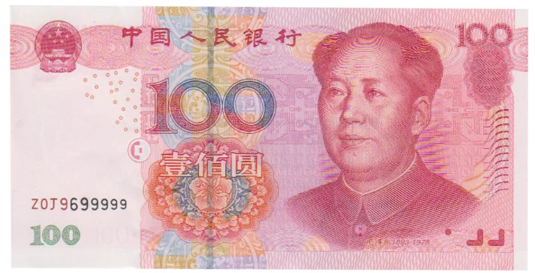

- 50RMB Note
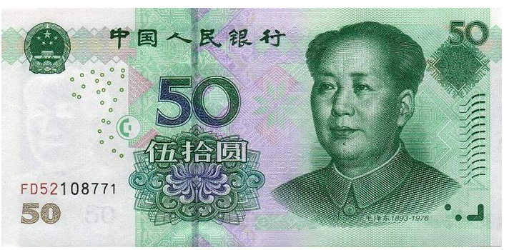

- 20RMB Note


10RMB Note
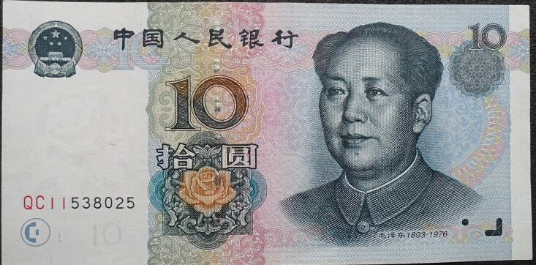

1RMB Note
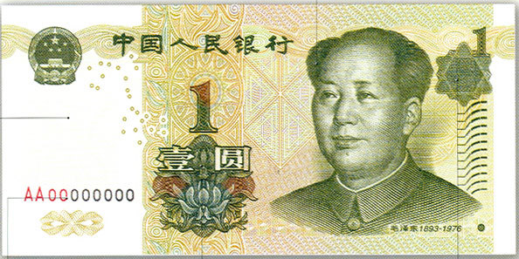

It is important to carry cash in China. Daily transactions are almost
always conducted in cash. Bank cards are only accepted by larger stores and some upscale restaurants and hotels, etc.

2) Banks & ATMs
When you open an account, the bank normally require a minimum deposit. For foreigners, passports are required to open an account. Make sure that you pay attention to all the details that the Bank Representatives tell you. You will be issued an ATM card upon the opening of your account. This card can be used at ATMs for both withdrawals and deposits of cash. Make sure to keep track of your card. Depending on the bank, it can take up to five working days to replace it when lost.

Currently there are 4 major banks in China: Bank of China, Industrial
and Commercial Bank of China, Agricultural Bank of China, and China Construction Bank. We have all the mentioned bank branches and ATM services on SYSU campuses.
South Campus | Service Hours | Address
ICBC | Weekdays 9:00-17:30  Weekends 10:00-16:30 | On the 1st floor of the Sir Run Run Shaw Art and Cultural Center
ABC | Weekdays 9:00-17:30  Weekends 10:00-16:30 | Same as above, just beside ICBC
BOC | Weekdays 9:00-17:30  Weekends 10:00-16:30 | Right outside the West Gate
CCB | Weekdays 9:00-17:30  Weekends 10:00-16:30 | Next to the West Gate
ATMs | 24 hours | Opposite to the supermarket in the East Area & on the 1st floor of the Sir Shaw Run Run Art and Cultural Center
North Campus | Service Hours | Address
BOC ATM | 24 hours | 1st floor of No.1 Student Dormitory
ICBC ATM | 24 hours | 1st floor of Staff Apartment Building
CCB ATM | 24 hours | 1st Floor of Xinglinge Restaurant
East Campus | Service Hours | Address
ICBC ATM | 24 hours | 1st floor, Building No.6, Ming De Yuan
ABC | Mon-Fri: 9∶00-17∶00  Sat 9∶00-15∶00 | Next to Vanguard Supermarket, North Commercial District
Zhuhai Campus | Service Hours | Address
ICBC ATM | 24 hours | 1st floor of Li Yuan 2nd Building
CCB ATM | 24 hours | 1st floor of Li Yuan 2nd Building
BOC ATM | 24 hours | 1st floor of the A Area of the teaching building

3) Bank Hotlines
There are bank branches in the neighboring area of each campus. For more information please contact the banks.
Bank | Hotline | Website
BOC | 95566 | http://www.bank-of-china.com/en/index.html
ICBC | 95588 | http://www.icbc.com.cn/ICBC/sy/default.htm
ABC | 95599 | http://www.abchina.com/en/
CCB | 95533 | http://www.ccb.com/en/home/index.html

7. Libraries
SYSU has four campus libraries and three specialized libraries focusing on economics and management, biology, and chemistry. With a total floor space of more than 100,000 square meters, the library system contains 4.91 million published volumes and electronic resources totaling 8964 gigabytes. The University has a sizable campus high-speed internet network, covering the four campuses with over 74,000 network access points, among the most of any Chinese university.

1) Opening Hours
The libraries are wealthy in literary resources. They have a wide range of items including ancient books, Chinese paper journals, Chinese electronic journals, foreign e-books, CD/DVDs and network databases. In general, access to the libraries is restricted to members of the Sun Yat-sen University community. Non-members are advised to consult the admissions office regarding individual library policies. Opening hours vary in different campuses and during vacations. Should there be any change to the opening hours during special holidays, separate notices will be given on the website and also outside the libraries.
Library | Service Hours | Contact information
South Campus | Mon-Sun 7:30-22:30 | 020-84112094
North Campus | Mon-Fri 7:30-22:30  Sat 8:00-17:30  Sun 8:00-22:30 | 020-87331551
East Campus | Mon-Sun 8:00-22:30 | 020-39332622
Zhuhai Campus | Mon-Sun 8:00-22:30 | 0756-3668059  0756-3668020  zlib@mail.sysu.edu.cn

2) How to Apply For Borrowing Privileges
You first must obtain a campus card. You can then go to the front desk at the library and ask for a form to authorize your card to borrow materials. You must fill out the form and get it stamped by your school or department. After it has been approved, take it back to the library with your student ID and passport. Your campus card can then be activated as a library card.
Note:
- A library card can be used to borrow 10 books at the most.
- The period for keeping the borrowed books is 60 days. Students
should renew the books if they want to keep them longer. Otherwise, a fine will be imposed in accordance with the relevant regulations.

8. Shopping in 4 Campuses
Supermarkets, stores and bookstores are available on the campus. You
can purchase daily necessities in the supermarkets, including food, drinks, batteries, cups, towel and so on.
1) South Campus
Inside the South Campus are two supermarkets offering fresh fruit,
packaged food, sundries, liquor and housewares. The larger supermarket is in the student residential area about 100 meters from the small north gate. Near the supermarket you can also find many other shops, such as a stationary store, computer supply shop, bakery, dry clearner, and milk shop, etc. The smaller supermarket is on the west side of the campus.

Scattered throughout the campus are banks, hair salons, phone stores, copy shops and convenience stores. The convenience store behind the School of Foreign Languages and near the foreign students’ dormitory carries many foreign snacks and a few items not available in supermarkets such as butter and cream cheese. Two bicycle repair shops also serve people living around south campus.

Outside the small northwest gate is a large fresh market. Outside the west gate there is a large supermarket called Parknshop.
2) North Campus
The campus is in the center of Guangzhou near all amenities of the city. You can easily find shops in and around the campus that are within walking distance.
- Xinling Supermarket: located in the campus, opposite the School of Public Health.
- Shops outside the campus: outside the east gate you can find a number of small shops where you can buy a various stuff.

3) East Campus
East campus is near a large commercial area serving the University City with shopping, dining and cinemas. Here are some examples of the shops that can be found near the campus.
- GoGo New Plaza: Located in the living area, including McDonald’s, Mannings, 7-11 store, etc.
- Happy More Supermarket: Located in the 2nd floor of Zhi Shan Yuan, where a variety of goods can be found, such as foods, fruit, drinks, etc.
4) Zhuhai Campus
The Zhuhai Campus has a commercial center with a supermarket,
computer repair shop, gift store, book store, bakery, hair salon, post office and phone shop. Fresh fruit and other common goods are available at lower prices outside the north gate of the Zhuhai campus.

9. Sports
Sports stadiums and gymnasiums are mainly used for P.E. courses during teaching hours and for public sports after class. You can go to the Office of Sports Venue Management at the Department of Physical Education (or Campus) in advance to apply for access to sports venues. Sports stadiums and gymnasiums are open to the public on weekends (charging fees)
1) South Campus
South Campus Henry Fok Sports Center includes Henry Fok Gymnasium, Henry Fok Stadium, tennis courts, multi sports ball courts, swimming pool and administration building.
2) North Campus
The North Campus is the smallest of SYSU’s campuses, but still
includes a full scale track for students and community members to exercise.
3) East Campus
The East campus gymnasium is located in the middle of the campus. Sports facilities include stadiums, football fields, volleyball courts, basketball courts, badminton courts, ping-pong tables, baseball fields, softball fields, swimming pool, gym, artistic gymnastics room, strength training room, water sports center and multifunctional sports gymnasium.
**You can apply for a pass to the swimming pool in the campus gymnasium. For more information, please contact their staff on 020-39347778.
4) Zhuhai Campus
The Zhuhai Campus Gymnasium covers an area of nearly 9,000 square
meters: 120m in length and 70m in width. It has basketball courts, volleyball courts, tennis courts, badminton courts and ping-pong tables, providing an all-day long sports training and competition venue on campus. There is also a football field, stadiums, and other sports facilities.

10. Campus Shuttle Buses
Shuttle bus service is offered among the four campuses. The bus
terminals in the four campuses are listed as follows:
1) South Campus
Terminal: Kee Kwan Coach Station (near the south gate)
- To the East or North Campus:
On weekdays, an express shuttle bus travels between south campus
and other campuses in Guangzhou. It costs 3 Yuan to go to east campus and it takes approximately 30 minutes. For travels between south campus
and north campus, it is free of charge for the university staff and students.
- To Zhuhai Campus
A full-fare ticket for travelling between South campus and Zhuhai campus is 70Yuan, while using a campus card will reduce the fare to 40 Yuan. It takes about 2 hours to go to Zhuhai Campus. For ticket booking, please contact the ticket office in the station on 020-84113811.
2) North Campus
Terminal: The South Gate
3) East Campus
Terminal: The Teaching Building
Ticketing office: 020-39332600
4) Zhuhai Campus
Terminal: The Teaching Building
Ticketing Office: 0756-3610489
5) Timetable
For detailed shuttle timetables, please refer to the website:
Shuttles between campuses in Guangzhou:
http://home3.sysu.edu.cn/zwc/news/news01/46222.htm
Shuttle between Zhuhai Campus and other campuses
http://zhhq.sysu.edu.cn/hqdt/zxdt/20307.htm

11. Social Media
For up-to-date campus news, activities and various information, please stay tuned to SYSU’s official website and social media accouts:
- SYSU official website: www.sysu.edu.cn
- Office of International Cooperation & Exchange website:
http://eao.sysu.edu.cn/index.htm
- Office for International Students’Affairs website(ISO):
http://iso.sysu.edu.cn/
- Facebook: facebook.com/sysuworld
- Twitter: twitter.com/sysuworld
- Instagram: instagram.com/sysuworld
- Youtube: youtube.com/sysuworld
- International Student Blog: www.sysustudent.net
- ISO webchat：sysuworld

Here are the scan codes of some SYSU social media accounts：







Part 5: Life in Guangdong
1. Transportation
Public transportation can seem overwhelming at first, but after a short learning curve, you will find that the network of transportation options is both extensive and intuitive. Here is a brief introduction to the major transportation options in Guangzhou.

1) How to Purchase and Use Yang Cheng Tong
The transportation card for Guangzhou is called a Yang Cheng Tong. The pass is essential for travel on buses and subways in the city, and can also be used for purchases at some convenience stores. Passes can be purchased inside subway stations at 7 Elevens or other shops. They can be reloaded at the same shops in increments of 50 RMB. The pass provides a 5 percent discount on the subway, and after the 15th use of each month, it becomes a 40 percent discount on the bus and subway.

2) Guangzhou Metro
The Guangzhou Metro is very user friendly. Stations are new and modern, and transfers and exits are clearly marked. Fares depend on distance travelled, starting at 2 RMB and ranging from 2 – 8 RMB for typical journeys. Trains run from early morning to around 11 PM, with intervals ranging from 2 – 6 minutes. Particularly busy transfers, such as Tiyu Xilu Station, tend to get crowded during peak traffic times. The subway typically runs from around 6 AM to 11 PM, but specific times vary based on the line.
South Campus is located on Line 8 (the turquoise colored line). The West and South (Main) Gates are located closest to Sun Yat-sen University station and the East Gate is closest to Lujiang station. East Campus is located on Line 4 (emerald green). The campus is best accessed from Guangzhou Higher Education Mega Center North station. North Campus is located on Line 1 (yellow). The campus’s south gate is located near to Martyr’s Park station.
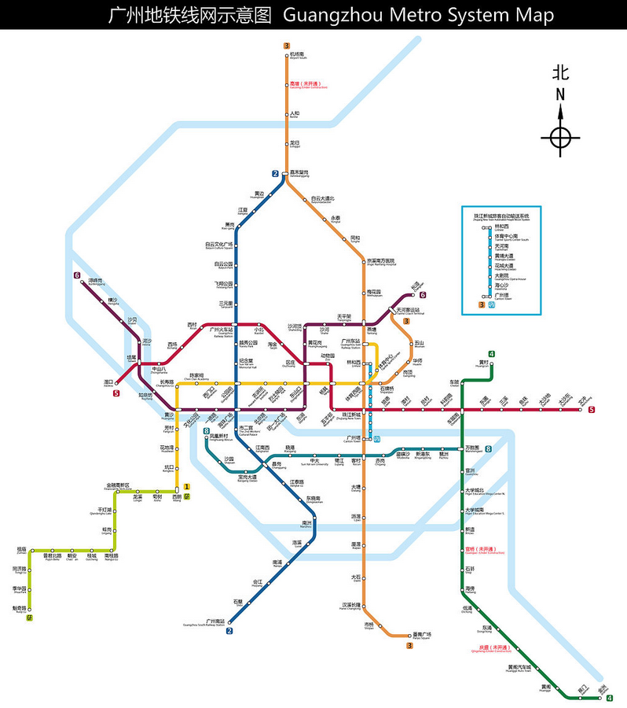

3) City Bus
At first, public buses may seem more difficult to use than the subway, but their coverage is much more extensive. To ride the bus, enter in the front door and pay 2 RMB cash or tap your Yang Cheng Tong. When you have arrived at your destination, always exit from the back door. For new users, the easiest is to download at app like Baidu Maps, which can give route options between two destinations. Buses typically run from 6 AM to around 10 PM, but times vary based on the route. Buses with the “Night” designation often run throughout the night, but at a lower frequency. Night buses cost 3 RMB. In Zhuhai, the bus fare is around 2-3 yuan.
- South Campus
The following bus routes stop at Sun Yat-sen University bus station, near the south gate of the South Campus:

      - 14
      - 69
      - 93
      - 184
      - 190
      - 206
      - 226
      - 250
      - 270
      - Night 29
      - Night 37

The following bus routes stop at Sun Yat-sen University North Gate bus station:

      - 8
      - 11
      - 24
      - 121a
      - 121
      - 131a
      - 182
      - 229
      - 247
      - 266
      - Night 6
      - Night 42

The following map shows some stations around SYSU’s South Campus. Red dots are eastbound stations and blue dots are west bound stations.

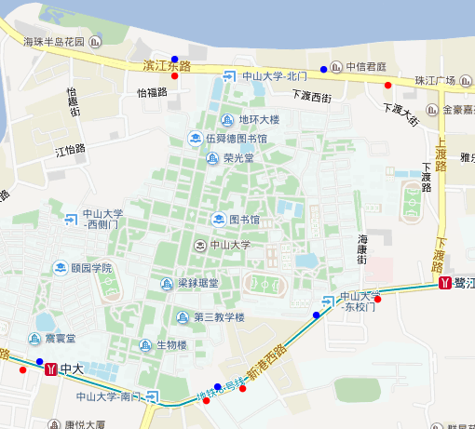

- North Campus
The following bus routes stop at Sun Yat-sen Medical University station, located near the campus’ south gate:

      - 16
      - 183
      - 222
      - 223
      - 502
      - 517
      - 535
      - B8
      - Night 27
      - Night 2
      - Night 36
      - Night 39
      - Night 40
      - Night 9

These routes stop at Zhixin Lu station, outside the campus’s north gate:

      - 27
      - 54
      - 56
      - 62
      - 112
      - 189
      - 204
      - 247
      - 284
      - 287
      - 293
      - Night 18
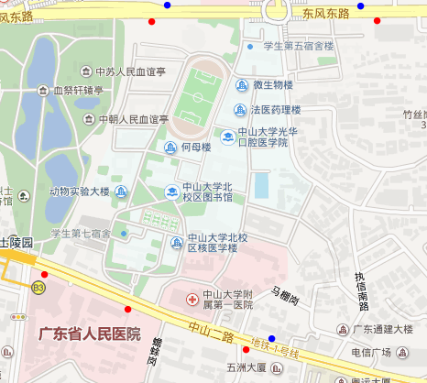
Here is a map of North Campus, with nearby bus stations similarly marked.

- East Campus
East campus can be reached by bus routes 381, 382, 383, 332,
University Mega Center line 1 and line 3.

- Zhuhai Campus
There are 2 bus stops near the campus, one is called “Sun Yat-sen University Stop” and is located outside the east gate. Bus lines 3、3A、10、10A、66、68、69、K1、K3 stop here. The other one is located near the south gate, with bus lines 7, 66 and 85 stopping here.

4) Taxis
Taxis are a popular option for cross-town transportation. Taxis can be hailed on almost any street in the city. Fares start at 10 RMB and a cross-town journey in Guangzhou rarely exceeds 40 RMB. If you cannot tell the driver your destination in Chinese, be sure to prepare a written address or name.

5) Bicycles
Many students use bicycles for transportation in and around the campus. Bikes can be purchased and maintained fairly cheaply. Safety is a concern, and bikes should always be securely locked, or else brought in side when not in use. Inside the SYSU campuses, bike traffic flows easily. Outside the campus, most places do not have bike lanes and bikers should exercise caution.

6) Airport and Train Stations
Baiyun Airport is located in the north of Guangzhou and is accessible by Guangzhou Metro Line 3. Zhuhai has a smaller airport serving mailnly domestic destinations. There are three major train stations in Guangzhou and one in Zhuhai:
- Guangzhou Railway Station: Located in the city’s northwest, this is the base for most conventional rail long distance train journeys. The station is located on the interchange between metro lines 2 and 5.
- Guangzhou East Station: This station is located in Tianhe and is the base for the high-speed shuttle service to Shenzhen as well as the city’s direct rail link with Hong Kong. The station is located on the interchange between metro lines 1 and 3.
- Guangzhou South Station: This is the cities major long distance high speed rail station, with services north all the way to Beijing. This station is located on metro line 2. This is also the northern terminus of the Guangzhou-Zhuhai Intercity Shuttle train.
- Zhuhai Railway Station: Located adjacent to the boundary with Macau, this station is the southern terminus of the Guangzhou-Zhuhai Intercity Shuttle train. Zhuhai North Station is located in the north of the city, and is also located on the Guangzhou-Zhuhai Intercity route.

2. Legal Matters

1) Immigration Bureaus
Many official immigration procedures are handled at the immigration bureaus in Guangzhou and Zhuhai.

Immigration Bureaus | Address | Tel
Division of Aliens and Exit-Entry Administration of Guangzhou Municipal Public Security Bureau | 6th floor, No. 155 Jiefang Rd., South, Guangzhou | 020-83115755  020-83115894  020-83115895
Division of Aliens and Exit-Entry Administraion of Zhuhai Municipal Public Security Bureau | No. 493, Xinghua Rd., New Xiangzhou, Zhuhai City (South Gate of the Sports Center) | 0756-8640557 or 008640558

2) Consulates Located in Guangzhou
The following countries have consulates located in Guangzhou:
Country | Tel | Country | Tel
United States | +86-020-81218000 | Japan | +86-020-83343009
Thailand | +86-020-83804277 | Poland | +86-020-81219993
Australia | +86-020-38140111 | Vietnam | +86-020-83305911
Malaysia | +86-020-38770765 | Germany | +86-020-83180000
United Kingdom | +86-020-83143000 | France | +86-020-28292000
Philippines | +86-020-83311461 | Netherlands | +86-020-38132200
Canada | +86-020-86660569 | Cambodia | +86-020-83879005
Denmark | +86-020-86660795 | Italy | +86-020-38396225
Korea | +86-020-38870555 | Indonesia | +86-020-86018772
Finland | +86-020-38770188 | Switzerland | +86-020-38330450
Belgium | +86-020-38772356 | Singapore | +86-020-38912345
Cuba | +86-020-22382603 | New Zealand | +86-020-86670253
Russia | +86-020-85185001 | Greece | +86-020-85501114
India | +86-020-85501114 | Austria | +86-020-85501501
Norway | +86-020-38113188 | Kuwait | +86-020-28078070
Mexico | +86-020-22081540 | Pakistan | +86-020-85505679
Israel | +86-020-85130509 | Spain | +86-020-38929809
Ethiopia | +86-020-38350575 | Argentina | +86-020-38880328
Ecuador | +86-020-38927650 | Brazil | +86-020-83652236
Chile | +86-020-38928270

2) Emergency Numbers
Service | Telephone

Police | Tel: 110
Fire Service | Tel: 119
Ambulance | Tel: 120

3. Entertainment

1) Sports
- Guangzhou professional teams
Guangzhou residents are very proud of Guangzhou Evergrande, a member of the top level Chinese football (soccer) league. The team has achieved success not just in China but also in Asia and plays its home games in Tianhe’s Sports Center.
- Sporting venues in the city
Most sports facilities are clustered in the Sports Center in Tianhe. Here there are opportunities to watch high-level sports matches and to play basketball, football, baseball, tennis, table tennis, and bowling.

2) Culture
- Cultural Institutions
Guangzhou is home to a number of cultural institutions, the crown jewel being the Zaha Hadid designed Guangzhou Opera House in Zhujiang New Town. Provincial and Municipal museums and concert halls are scattered throughout the city, including:
- Chen Clan Ancestral Hall
- Guangdong Museum
- Guangdong Provincial Museum
- Museum of the Mausoleum of the Nanyue King
- Zhenhai Tower
- Guangzhou Art Museum
- Xinghai Concert Hall
- Peasant Movement Institute

3) Cinema
Movie theaters in Guangzhou usually have one or two major American blockbuster films at any given time. Chinese productions are always available as well, with some Cantonese language films from Hong Kong screened at select theaters.

4) Nightlife
- Guangzhou
Popular areas for night life in Guangzhou are Zhujiang New Town (the city’s financial district) and Taojin, a district which is home to a large expat population. Closer to the south campus, there are several bars geared toward student budgets located outside of the Small North Gate, including Perry’s, the perennial favorite watering hole for SYSU international students.
- Zhuhai
Zhuhai is famous for its varied nightlife. For pubs, clubs, and live music venues, your best bet is a visit to the aptly named “Bar Street” (jiuba jie). Another popular choice is karaoke (KTV), which can be found in all the major commercial districts in the city.

5) Recreation and Sightseeing
- Guangzhou
The following places are famous throughout Guangzhou and around
the country. As you settle in to your life at SYSU, take some time to visit them and check out what makes the city special:
- Baiyun Mountain: Located in the north of Guangzhou, Baiyun Mountain is a famous destination for those looking for relief from the city. It’s a great place to go hiking, walking, and sightseeing, and also provides a great chance to get some fresh air.
- Guangzhou Tower: This has fast become an icon of Guangzhou. It is among the tallest human made structures in the world, reaching over 600 meters. The rainbow colored tower can be spotted from almost anywhere in the city, and the viewing platform on top provides unparalleled views of Guangzhou.
- Sun Yat-sen Memorial Hall: SYSU is not the only institution in Guangzhou that pays homage to the great Dr. Sun Yat-sen. Located in Guangzhou’s old city on metro line 2, this memorial hall was erected in memory of Dr. Sun and its blue roof is now a famous symbol of the city. Finished in 1931, it has served many functions over the course of its life, including serving as the site of the surrender of Japanese forces in Guangzhou at the end of World War II.
- Xiaozhou Village: If you are looking for a glimpse at the China of centuries past, Xiaozhou Village is a great place to see it. Founded in the time around the end of the Yuan Dynasty and beginning of the Ming Dynasty, the village typifies the architectural styles commonly found in the Guangdong region during that time.
- Shamian Island: Originally home to Western factories, Shamian Island retains the old world feel of a European city. The island is full of examples of French and British colonial architecture and is dotted with cafes, restaurants, and bars. The island has also become a favorite spot for romantic getaways, and is also frequently used as a backdrop for wedding photos.
- Museum of the Mausoleum of the Nanyue King: In 1983, while excavating a site slated for development, workers stumbled upon a historical treasure unlike any seen before in Guangzhou: the Mauseleum of the Nanyue King. Dating back to when Guangzhou was the capital of the independent southern Chinese kingdom of Nanyue, the museum provides a fascinating look at a wide variety of artifacts dating back over two thousand years.
- Chen Clan Academy: During imperial times, those who wanted to join the official bureaucracy were subjected to exhaustive tests of the Confucian classics. One family, the “Chen Clan”, established an extensive study hall in 1888 for young members to prepare for the exams. Although the imperial exams were abolished soon thereafter with the advent of Sun Yat-sen’s republican revolution, the hall still stands to this day. It is now the home of the Guangdong Folk Art Museum

- Zhuhai
- Jintai Buddhist Temple: Zhuhai may seem like a city where everything is brand new, but the Jintai Temple is over 1000 years old. Built during the Song dynasty, the temple is a soaring example of what most foreigners think about when they imagine traditional Chinese architecture. Despite the temple’s long history, it is still in use, and hums with activity on a daily basis.
- Island Hopping: Unlike Guangzhou, Zhuhai is a city on the sea. The jagged nature of the Southern Chinese coast means that the area is dotted with islands large and small. Many of these islands are accessible by ferry, providing a great opportunity for swimming, sunbathing, and diving.
- New Yuanming Palace: Modelled after the Yuanming Palace in Beijing, this is no mere museum. The palace is a thriving tourist attraction, with a diverse array of entertainment options, including boat rentals, musical theater, and war re-enactments. You even have the option of getting your picture taken while wearing imperial-style robes.

4. Dining

1) Cantonese Cuisine
Cantonese cuisine is famous throughout China and around the world. It is noted for its attention to fresh ingredients and its insistence on light, clean flavors. The variety of Cantonese cuisine on offer is astounding, and familiarizing yourself with the options is one of the joys of living in Guangzhou and Zhuhai.

2) Types of Restaurants
Some major types of Cantonese restaurants include:
- Dim Sum: often eaten in the morning or midday, includes a wide variety of steamed and fried dishes.
- Fast food: Cantonese fast food includes items like rice rolls, rice congee, and wonton soup. Popular chains are found through the city, including “Hua Hui Rice Roll” and “Number One Noodle”, both of which have locations near the SYSU South Campus.
- Banquet style: This is a white table cloth style of restaurant that serves Cantonese barbequed meats and steamed seafood dishes, in addition to fresh vegetables, fried dishes and other staples.

3) Recommended Restaurants in Guangzhou
Three restaurants that are famous city-wide for their history and quality are:
- Nanyuan Restaurant, 020-84448380
- Guangzhou Restaurant, 020-81380388
- Tao Tao Ju, 020-81389632

